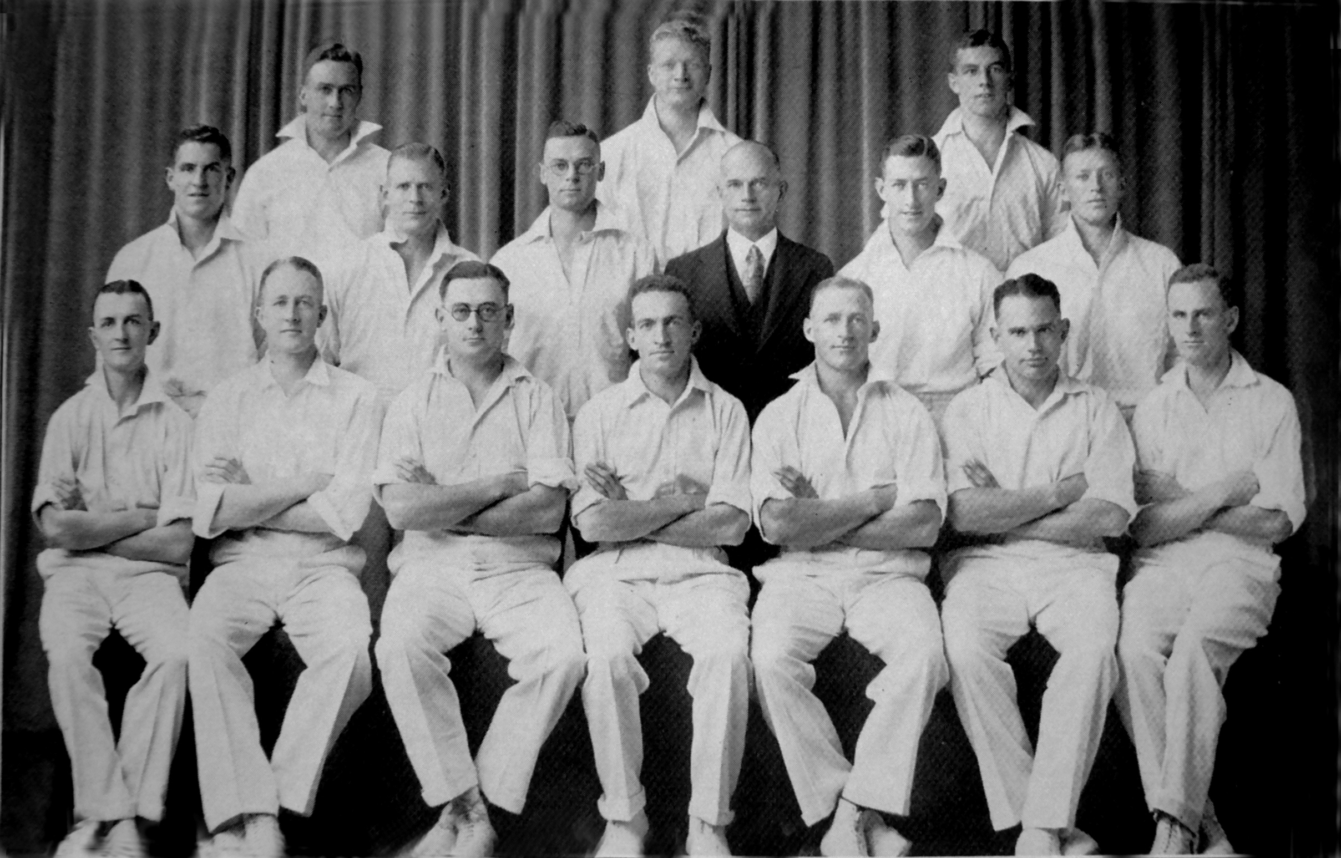

**Canterbury Representative Team 1934-35**

Winners of the Plunket Shield

**Back row:** CK Jackman, PF Allen, LH Fisher,

**Middle row:** S Andrews, JL Kerr, WA Hadlee, CH Ayling (manager), FP O’Brien, LA Butterfield

**Front row:** FW Bellamy, SG Lester, IB Cromb, ML Page (captain), CJ Olliver, AW Roberts, M Graham